Ideation phase
Weather-Based Prediction of Wind Turbine Energy Output: A Next-Generation Approach to Renewable Energy Management

Project Title: Weather-Based Prediction of Wind Turbine Energy Output: A Next-Generation Approach to Renewable Energy Management
Brainstorm
STEP-1: Problem Statement:
Problem Statement
Wind turbines generate electricity based on weather conditions, especially wind speed. Since weather changes frequently, the amount of energy produced by wind turbines also changes.
Because of this, energy companies face problems in:
- Predicting how much electricity will be generated
- Planning maintenance at the right time
- Managing and balancing the power grid
If predictions are not accurate, it can lead to power shortages, higher costs, and inefficient energy management.
So, this project aims to build a machine learning model that can predict wind turbine energy output using weather data. This helps improve energy planning, reduce losses, and support better renewable energy management.
Idea Listing and Grouping:
Team Leader: Garaboyina Mohitha Sree:
Idea-1: Basic ML model using Linear Regression
Idea-2: Ensemble Model (Random Forest + XGBoost)
Team member: Konagala Mounika Krishna
Idea-1 :Time Series Forecasting using LSTM
Team member : Peyyala Pardhasaradhi
Idea-1 :Real-time Weather API Integration
Idea-2: Smart Maintenance Alert System
Team member : Navya Bandela
Idea-1: Dashboard for Grid Operators
Possible ways:
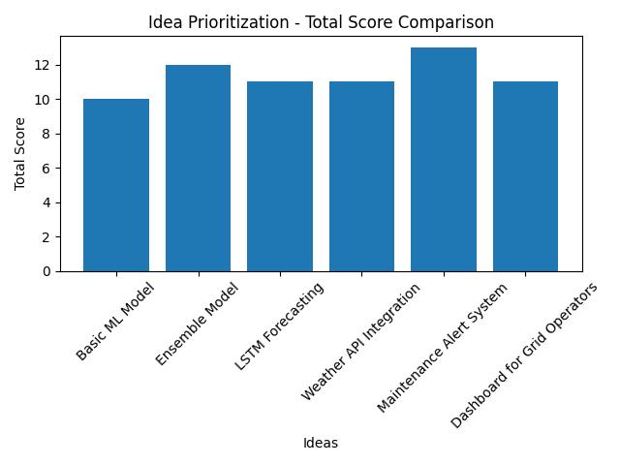
STEP-2: Output:

STEP-3: Technologies Used:
- Python (Pandas, NumPy)
- Machine Learning (Linear Regression, Random Forest, XGBoost, LSTM)
- Data Visualization (Matplotlib, Seaborn)
- Deployment (Flask, Streamlit)
Define problem statement:
1. Current Situation
Wind turbines generate electricity based on weather conditions such as wind speed, wind direction, and temperature. However, weather conditions are unpredictable, causing fluctuations in energy production.
2. Existing Problem
Due to these fluctuations, energy companies and grid operators face difficulties in accurately forecasting power generation, planning maintenance schedules, and balancing electricity supply and demand.
3. Impact of the Problem
Inaccurate predictions can lead to power shortages, increased operational costs, inefficient grid management, and revenue loss.
4. Required Solution
There is a need to develop a machine learning-based predictive system that can accurately estimate wind turbine energy output using historical and real-time weather data
Real-World Applications
- Energy Production Forecasting – Helps energy companies predict power generation.
- Maintenance Planning – Schedules maintenance during low wind periods.
- Grid Integration – Assists grid operators in balancing supply and demand

